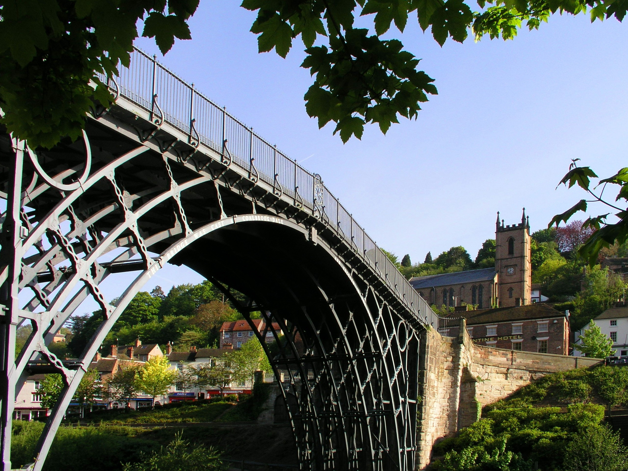
The Chez Maw Restaurant

Mother’s Day 2020

Award winning Two AA Rosette Restaurant using only the finest quality ingredients.

£25.95 per adult
£16.00 per child under 12

The Chez Maw Restaurant
Best Western Valley Hotel
Buildwas Road
Ironbridge
Telford
TF8 7DW
Tel: 01952 432247
Fax: 01952 432308
Email: sales@thevalleyhotel.co.uk
www.thechezmawrestaurant.co.uk

Please make us aware of and special requirements or allergies. Dishes containing nuts are highlighted in bold

Mothers Day Sunday Lunch 2020

Starters

Chicken liver parfait, apple chutney, toasted sour dough

Oat crusted mackerel bruschetta, tomato, aioli

Goats cheese leek tart, onion, dressed salad

Ham hock black pudding pressing, duck egg salad, brown sauce

Cauliflower soup, toasted croutes

Main course

Roast sirloin of beef, yorkshire pudding, red wine gravy

Seabass fillet, smoked haddock spring onion croquette, crab bisque

Roast loin of pork, sage & onion stuffing, baked apple puree, gravy

Pulled shoulder of lamb, dauphinoise potato, onion puree, braising sauce

Mushroom wild garlic, arancini, parmesan, tomato sauce

Desserts

Sticky toffee pudding, vanilla ice cream, caramel sauce

Chocolate baileys set custard, salted caramel cookie

Lemon tart, clotted cream

Rhubarb fool, poached rhubarb, spiced ginger loaf

Selection of Artisan Local Cheeses
Biscuits, celery, chutney

Shropshire Coffee and Petit Fours

Please make us aware of and special requirements or allergies. Dishes containing nuts are highlighted in bold

£25.95 per adult £16.00 per child under 12

